Master’s Thesis Template

Master’s Thesis
By

Author and Author
(Template by Peter Nilsson, updated 2015-11-26)

Department of Electrical and Information Technology
Faculty of Engineering, LTH, Lund University
SE-221 00 Lund, Sweden

 |  | Another logo, e.g. company or other university. Check if they allow it!

2015

Abstract
Here are my most important results described. The abstract is usually without abbreviations and references.

Acknowledgments
This Master’s thesis would not exist without the support and guidance of …

Name of the Authors

Contents
Abstract 3
Acknowledgments 4
Contents 5
Preface (if necessary) 7
List of figures (Not necessary) 8
List of tables (Not necessary) 9
List of acronyms (Not necessary) 11
Popular Science Summary 12
1. Introduction 13
2. Before the thesis work can start 14
3. Cross references 16
3.1. Figures, tables, and captions 16
3.2. Headings and Table of Contents 17
3.3. Cross references to figures and tables 17
3.4. Cross-references to references and equations 18
3.5. References and equations 19
3.6. Equations 19
3.7. Update Field 20
4. About writing a Master’s Thesis 22
4.1. Format 22
4.2. Hints about the writing 22
4.3. Figures 23
4.4. Should it be one or two thesis students? 24
5. The presentation 26
5.1. Presentation 26
5.2. Opposition 26
5.3. The procedure 27
5.4. Hints about the slides 27
6. Academic honesty 29
6.1. What is plagiarism? 29
6.2. How does Lund University work with plagiarism? 29
6.3. What does Lund University require from you? 29
7. Results 31
8. Conclusions 32
9. Future work 33
References 34
Appendix A: Extended material 35

Preface (if necessary)
This statement is a requirement if there are more than one thesis worker:
In this thesis work, author 1 has been working with X, author 2 has been working with Y, and part Z has been done together.

Here, scientific and popular papers contributing to this thesis can be listed, submitted papers as well.

List of figures (not necessary)
First time: Go to the References tab. Press Insert Table of Figures. Press Options and choose Style New Figure Caption. Press NO on Do you want to replace … if it appears.
After that: Right click on the table and Update field.

Fig. 1. The project plan for the thesis work. 15
Fig. 2. A Gantt chart over the project plan. 15
Fig. 3. Three objects before the Eclipse. 16
Fig. 4. Three objects after the Eclipse. 17
Fig. 5. Reference to a heading in (a) and to a figure in (b). 18
Fig. 6. Reference to a Reference in (a) and to an Equation in (b). 19
Fig. 7. A figure with too small text 24
Fig. 8. An example on a figure, which is not acceptable. 24

List of tables (not necessary)
First time: Go to the References tab. Press Insert Table of Figures. Press Options and choose Style: New Table Caption. Press NO on Do you want to replace … if it appears.
After that: Right click on the table and Update field.

Table 1. The objects before eclipse. 16
Table 2. The objects during eclipse. 16
Table 3. Table for equation numbering 18
Table 4. Example of rounding percentages 27

List of acronyms (not necessary)
CDMA Code Division Multiple Access
CMOS Complementary Metal Oxide Semiconductor
GSM Global System for Mobile Communications
PDA Personal Digital Assistant
UWB Ultra Wide Band Technology

Popular Science Summary
This thesis work is about …

Introduction
This chapter gives a brief description of the project …

Note that each new chapter should appear on an odd page (even if it is not so in this document)

Before the thesis work can start
The initial steps, based on new guidelines 2014, are basically as follows:
- Students bring the form "Anmälan - examensarbete" to utbildningsservice. The program planners are
  - Nora Ekdahl for C and D,
  - Åsa Vestergren for E, BME,
  - Helene von Wachenfelt for MSOC, and MWIR,
  - Johan Hugosson for F and N.
- The program planner checks that the student has the required prerequisites and signs a dedicated part of the form. Master students bring the form to the international office and have it signed there.
- When the form has been signed, the work with constructing the goal document can begin.
- When the goal document has been approved by both the examiner and the supervisor, the project can be registered. This is done by handing the form to Marianne Greiff Svensson.
The most important part above is that no actual work should start before utbildningsservice (international office) has checked the formal prerequisites.
Note that you cannot be registered to the thesis work before these initial steps are done and you will not get access to the thesis rooms before you are registered.
The goal document should include a project plan, as shown in Fig. 1. The figure is just to give a hint, i.e. it must be more detailed.
Project plan:
Task 1: 19th Jan – 16th Feb:
- Literature study
- Theoretical investigation of …
- …
Task 2: 17th Feb – 20th March:
- Simulation of important algorithms in e.g. Matlab and C++ …
- Error analysis …
- …
Task 3: 21st March – 20th April
- Implementation of selected algorithms
- …
Task 4: 21st April – 20th May
- Validation of the simulation results from the implementation
- …
Task 5, 21st May – 20th June
- Completion of the thesis report that of course have been written since the first day of the thesis project.
- The project plan for the thesis work.
A Gantt chart is a nice presentation form to give an overview over the project plan as suggested in Fig. 2.
- A Gantt chart over the project plan.

To be continued …

Cross references

Figures, tables, and captions
Table 1 shows the objects in Fig. 3 and in Table 2, the objects in Fig. 4 are shown. Note that all figures and tables should be referred in the text, after appearance, like in this sentence.
- The objects before eclipse.
A | B | C
Using the IEEE standard, the table head font is in Small Caps using the font Times New Roman. Reformat the style to change.
- The objects during eclipse.
1 | 2 | 3
In Fig. 3, there are three objects before the eclipse. In Fig. 4, there are three objects after overshadow.
- Three objects before the Eclipse.
The figure captions, in IEEE style, are written as “Fig. 1.” A figure is often referred in the text as “Fig. 1”, i.e. not as “Figure 1”. Whatever you choose, be consequent!
- Three objects after the Eclipse.

Headings and Table of Contents
In the Microsoft Word Home tab you can press the small arrow to the right under styles to see all styles for this document. Some of the styles are new which can be useful in this document. The headings, i.e., “Heading 1 chapter”, “Heading 2”, and “Heading 3”, are only slightly modified, mainly formatting.
To be able to generate a Table of Contents, you need styles for the different levels for the chapter and sections, see the styles New Heading 1, New Heading 2, and New Heading 3, in the styles menu. For unnumbered headings, use the style New Heading No Numbering. The unnumbered headings can be used for the abstract, acknowledgements, references, etc. To update the Table of Contents, go to the Table of contents and right click on one of the lines and click “Update field”.
To make a cross reference to a heading, for instance section 3.2, click the References tab followed by Cross-reference in the Captions group. In the Cross-reference window, choose Paragraph number and mark which numbered item you want, see Fig. 5a. Press the Insert button.

Cross references to figures and tables
To make a figure or table caption that is useful for cross references, New Figure Caption or New Table Caption in the Styles menu can be used. A cross reference is done by clicking the References tab followed by Cross-reference in the Captions group. In the Cross-reference window, choose Paragraph number and mark which numbered item you want, as shown in Fig. 5b.
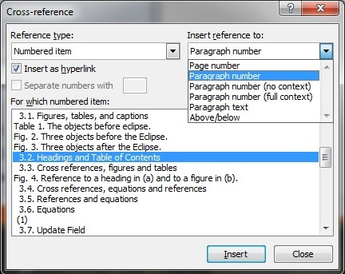  (a) | 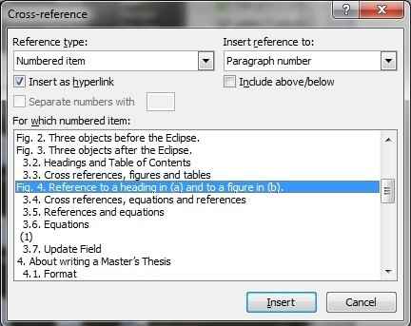  (b)
- Reference to a heading in (a) and to a figure in (b).

Cross-references to references and equations
To make a reference list, place the cursor at the end of the document, type “References” or “Bibliography”, click on New Heading No Numbering in the Styles menu, press the return key, click on New Reference List in the Styles menu and add references after that. In the text, insert a reference, e.g. [5], by using Cross-Reference as shown in Fig. 6a.
References to equations are trickier. When adding an equation number, a 1-row 2-column table is to prefer since the equation number is right adjusted and the equation is not, see Table 3. Adding an equation number is done by clicking the References tab followed by Insert Caption in the Captions group and klick OK, see Fig. 6b.
- Table for equation numbering
(1)
For some reason, the equation number will not stay in the table cell and there will not be any parentheses. Add parentheses and move the number to the table. In the following, copy and paste the table for new equations.
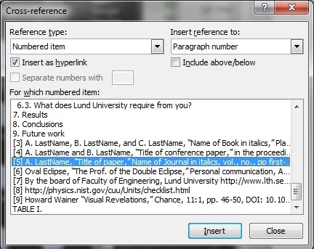  (a) | 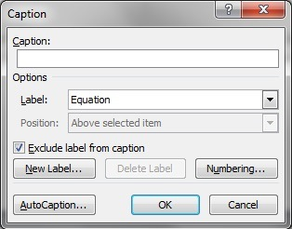  (b)
- Reference to a Reference in (a) and to an Equation in (b).
Cross references to (2) and (3), will thus look like (2) and (3).
(2)
(3)

References and equations
Follow the reference style for books [1], conference papers [2], and journals [3], when referring to a bibliography item. Note that the style differs between [1], [2], and [3]. There should not be any bibliography items that do not appear the text. If possible, avoid references to web-pages since they often become out of date. References are preferably not placed in abstracts, captions, headings, etc., only in the body text. Note that the references should be numbered in the order they appear.
If you take a copy of an original picture from a book, internet, etc. or if you for some reason rewrite it but “keep the content,” you can refer to it in the text like – there are no evidence for the double eclipse theory [5]. Another option is to refer directly in the figure like, see Fig. 4. To my knowledge, you have no obligation to ask permission from the original source, as long as your publication is not commercial.

Equations
All equations should be referred in the text, usually on the IEEE form: “The function is shown in (1)”, not as “The function is shown in equation (1)”, or “The function is shown in equ. (1)”. The only exception is when the sentence starts with a reference, i.e. “Equation (1), shows the function” is correct but not “(1), shows the function” in the beginning of a sentence.
(4)
It can be feasible to use automatic numbering of references and equations as well. Note that the references and equations should be numbered in the order they appear.
Variables are in most cases written in italics, however not numbers and parentheses, which should be written with italics and roman (non-italics) for the numbers, like the variable a₁(k), see (1). Matrices should be written in bold, but not in italics, like A, H, and X. Variables in digital design are large signal parameters. They are usually written with capitals, e.g. V_{DD}, V_{GS}, I_{D} etc. A style with roman subscripts is also practiced, e.g. V_{DD}, V_{GS}, I_{D}. Analog parameters are often small signal variables written as v_{ds}, v_{gs}, i_{d} etc.
Unit values and units are written without space, in the IEEE style, like 3V, 4mW, and 2µA. However, this is in the contrary to the SI standard [6]. The SI standard seems to be the most common style. The recommendation is thus to be consequent! Note that the units are in non-italics. Values like 35cm x 48cm, 1MHz to 10MHz, and 123g ± 2g are preferred, but not 35 x 48cm, 35 x 48cm², 1 to 10MHz, and 123 ± 2g.

Update Field
When changes are done in captions and cross references, the numbering might need an update. That can be done by right clicking in the text of the caption or cross reference. F9 updates the field as well and CTRL+a followed by F9 update all fields in the document.
To do a table of figures, click “Insert Table of Figures” in the “Captions” group, which will give the following result:
Fig. 1. The project plan for the thesis work. 15
Fig. 2. A Gantt chart over the project plan. 15
Fig. 3. Three objects before the Eclipse. 16
Fig. 4. Three objects after the Eclipse. 17
Fig. 5. Reference to a heading in (a) and to a figure in (b). 18
Fig. 6. Reference to a Reference in (a) and to an Equation in (b). 19
Fig. 7. A figure with too small text 24
Fig. 8. An example on a figure, which is not acceptable. 24

If anyone knows a better way to make cross references, I would be happy if you let me know!

About writing a Master’s Thesis

Format
The format of the thesis is 16.9 x 23.9 cm, like this template. The margins should be 2 cm on all sides. The text is preferably aligned to both right and left margins. The print will be two-sided, which affects the pagination, chapter pages, etc. That is, all page numbers cannot be to the right or to the left. They should be centered or alternating. Furthermore, if the first page of a chapter happens to be placed on a left page, a blank page should be inserted so that it will be placed on a right page. The front and back cover is designed by the printing office. Note that the thesis will be printed in black and white. A reasonable number of pages are around 50 to 100. The font is preferably 11pt Times New Roman, with single line spacing.

Hints about the writing
These hints are based on experiences that have been drawn from many first drafts of master’s theses. It is appreciated if you check them before you hand in your first draft.
In the area of Electrical Engineering, American English is commonly used.
The forms can’t, haven’t etc. are not used in technical writing. It should be cannot, have not etc.
Sentences should not begin with “So”, “And”, or “But”. “However,” can sometimes replace “But”. The word “so” should be excluded in the text as well since it is more like “spoken language”.
In American English, several listed possibilities should be written “a, b, and c”, note the comma after b, but not “a, b and c”, which is British English.
The words “I” and “we” can be used but not too often.
Avoid statements like “as described above”. It is better to write “as described in section x.y” or “as described on page z.”
Abbreviations should be defined first time they are used on the form “Device Under Test (DUT)” not “DUT (Device Under Test)”. It is also convenient for the reader have them redefined a few times later in the text.
The form for your work should be written as “… which is implemented …”, but when referring to another work the form should be as “… which was implemented by Smith”
A comma should separate in the case of “which” such as “A new method, which is good for …”, but not in the case of “that” like “A new method that is good for …”
Avoid expressions like “It is obvious that …”, “The rest is trivial”, “It is clear that …,” etc. especially if it is not like that.
Compared to or compared with? “Compared to” is the most commonly used when comparing statistical facts, results, etc. such as “Architecture A consumes 10mW, which is lower compared to architecture B that consumes 20mW.” “Compared with” is used for generalizations, such as “Compared with students in general; we are studying much more at home”.
To use “a” for consonants and “an” for vowels depends on how the word sounds, which in most cases are how it is written. However, a word like young is written “a young woman” and FFT is written “an FFT is used”.
Hyphens: When hyphenating a row, next row should start with a consonant followed by a vowel. Like syllabification can be hyphenated in many places, syl-la-bi-fi-ca-tion. The exception is when it is a compound word, like look-up table or astro-physics.

To be continued …

Figures
Fig. 5 shows a diagram, which is not acceptable. The text and the numbers on the axes are too small.
- A figure with too small text
Fig. 6 show another figure taken direct from an Electronic design automation (EDA) tool. It is very hard to follow the block diagram. Often it is better to draw it by hand in black on white background.
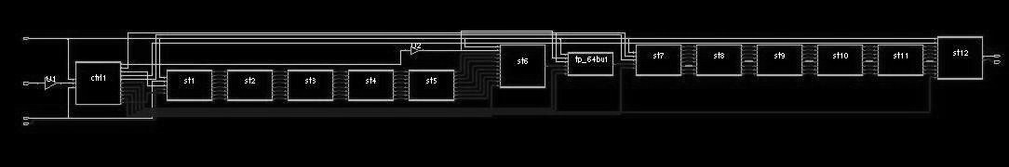
- An example on a figure, which is not acceptable.

Should it be one or two thesis students?
It is OK to be one or two master’s students in a thesis project. Two is to prefer since the project benefits from the interaction with each other. However, in the case of two students it is important to state how the work has been divided in the thesis, see the preface.

The presentation

Presentation
The presentation should NOT take more than 20 minutes. That means a maximum of 20 slides. Do a dry run in front of your friends before the presentation. Some hints:
- Start with a presentation of yourself.
- Content list can be used but it is not necessary. An alternative is to start by shortly answer the questions:
  - What?
  - Why?
  - How?
- Stand up and use the pointer.
- Switch the slides yourself.
- Talk in front of the audience.
- Do not read directly from a manuscript or the slides.

Opposition
You need to act as an opponent on another thesis work. It does not have to be in the same area as yours but it can be in the same area. To be approved on the opposition, you should ask about 5 relevant questions about the work. It should not be on the level “Here is a miss spelling.” Comments like that are appreciated and can be given to the presenter in person afterwards.
There can be opponents on your presentation but that is not a requirement.

The procedure
The usual procedure is like:
The supervisor or examiner takes a few minutes to present you.
The thesis worker(s) presents the work within 20 minutes.
The opponents, if any, ask their questions.
The rest of the audience can ask questions.
The examiner decides if you are approved on the presentation.

Hints about the slides
- All backgrounds are preferably white. Background color and patterns should be avoided.
- Colors can preferably be used to increase the clarity. Green color and light colors should be avoided.
- Animations can be used if it increases the clarity.
- Do not use too much text on the slides. It is better to split the slide into two.
- Figures are often better than text.
- Arial and Verdana are fonts that are recommended.
  - 36 to 44 pt for titles
  - 36 pt for sub-titles
  - 28 pt for major bullets
  - 24 pt for indented bullets
  - 24 pt (minimum) for text on graphs and figures.
Presenting results: Humans cannot understand more than two digits very easily [7]. Results in a table etc. should therefore be rounded. However, problems might arise when for instance percentages do not sum up to 100. This is often solved by adding or subtracting a value ε which is rounded again [7]. Table III shows an example. Note that in the thesis, the number of digits can be longer but only if they are significant.

- Example of rounding percentages
 | Value | Rounded | Add ε = 0.01 | Rounded
A | 40.43 | 40 | 40.44 | 40
B | 32.47 | 32 | 32.48 | 32
C | 16.99 | 17 | 17.00 | 17
D | 9.49 | 9 | 9.50 | 10
E | 0.62 | 1 | 0.63 | 1
Total (%) | 100 | 99 | 100.05 | 100

Academic honesty
Note that this chapter should not be in the thesis! It is just for information about what is allowed and not.
Every year the Disciplinary Committee of Lund University convicts and suspends 30-40 students because of plagiarism or other kinds of cheating. A fairly large number of all students that are caught for plagiarism at Lund University are exchange or master students from foreign countries. Exchange or master students are not more willing to cheat, but we are certain that because of different traditions at some universities, students might be caught cheating because of the very strict rules at Lund University.

What is plagiarism?
Plagiarism is the adoption or reproduction of ideas, words or statements of another person without acknowledgment of the original author or creator.
Three quick examples of plagiarism:
A false claim that you have written a paper, when it is in fact another student who has done all work. It is considered as plagiarism even if the other student has given his/her permission.
If you rewrite a section from a book/article/website without mentioning that the information is from that source.
To copy a section of a book/article/website without mentioning that the information is copied from that source.

How does Lund University work with plagiarism?
Lund University has a long experience of working against plagiarism. All mentors and teachers are educated to look for signs of plagiarism in the students’ work. As a complement Lund University also uses complex computer software to scan all essays to find traces of plagiarism.

What does Lund University require from you?
First of all, Lund University recommends you to pay attention to all information regarding academic writing that can be found on the university homepage (www.lu.se) and at the webpage of your specific department. You must always state the source when using other people’s work in your own text, regardless if the source is a book, a magazine article, the Internet or even a verbal communication. Any departure from this rule will be reported to the vice-chancellor who then reports to the Disciplinary Committee (Disciplinnämnden) at Lund University.
As long as you take notice of the rules of academic writing and implement these methods in your work you will not only be free of plagiarism, but also be able to publish a better essay. It is in your very best interest to read about academic writing and work in that manner.
Source: Lund University
More information is given in [5].

Results
A summary of your results is presented here.

Conclusions
A short summary of your work is presented here.

Future work
Here are your thoughts about a future continuation of your work.

References
- A. LastName, B. LastName, and C. LastName, “Name of Book in italics,” Place of Publication, Publisher, ISBN, year.
- A. LastName and B. LastName, “Title of conference paper,” in the proceedings of xxx xxx in italics, ISBN, pp. first-last, conference location, country, month and year.
- A. LastName, “Title of paper,” Name of Journal in italics, vol., no., pp first-last, ISSN, month and year.
- Oval Eclipse, “The Proof of the Double Eclipse,” Personal communication, April 2015.
- By the board of Faculty of Engineering, Lund University http://www.lth.se/fileadmin/lth/anstallda/projektdatabas/ak_hederlighet/PolicyPlagiarismLTH20100408.pdf
- http://physics.nist.gov/cuu/Units/checklist.html
- Howard Wainer “Visual Revelations,” Chance, 11:1, pp. 46-50, DOI: 10.1080/09332480.1998.10542079, 1993 and 1998.

Appendix A: Extended material
Some extra information for readers who would like more.

